Small user guide to PC Schematic.

Indhold

Setting the language to English. 1

Making shortcuts 3

Making a reference list 5

Symbol creator 5

Using the reference list 9

# Setting the language to English.

If PC Schematic is not set to english, it can be done as follows. The buttons are in the exact same place as in Danish, easy peasy.

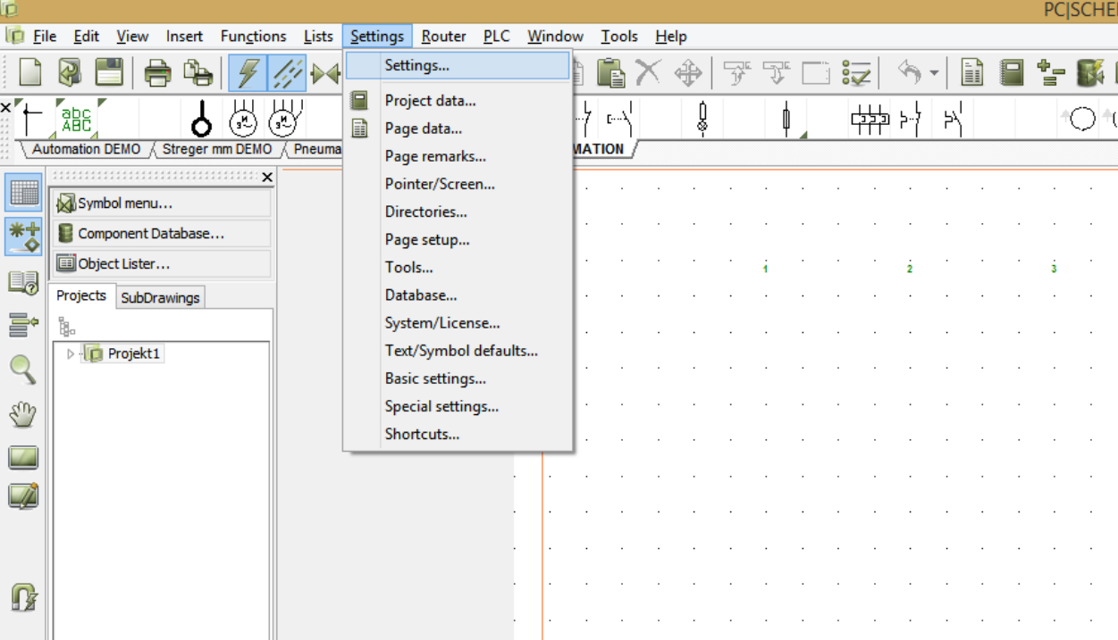

Select Settings, and settings

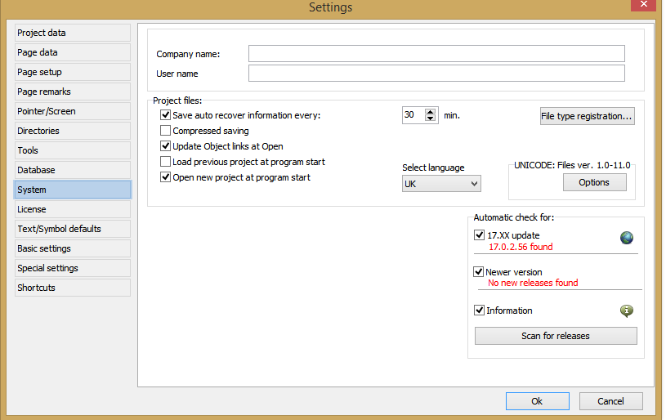System and then “Select language” and change it to UK.

# Making shortcuts

There is, by default no shortcut for the hand/ pan tool. To make a shortcut, hit “Settings” and “Shorcuts”

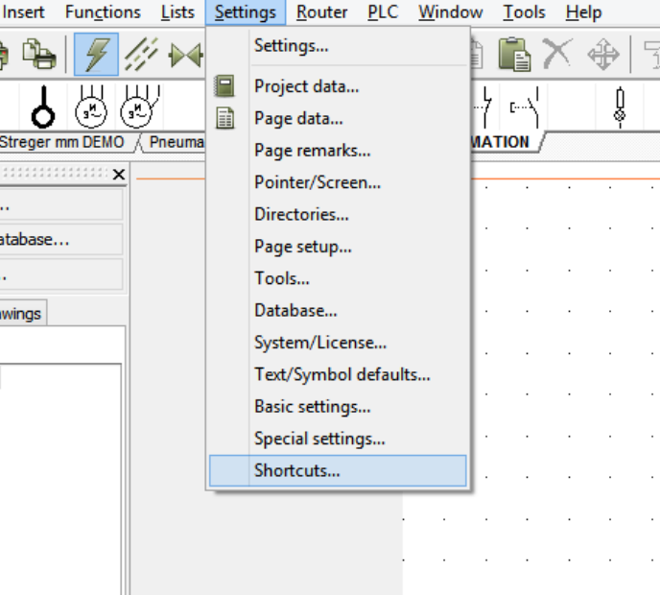

Then find the “All commands” and “Pan”. Enter a new shortcut key.

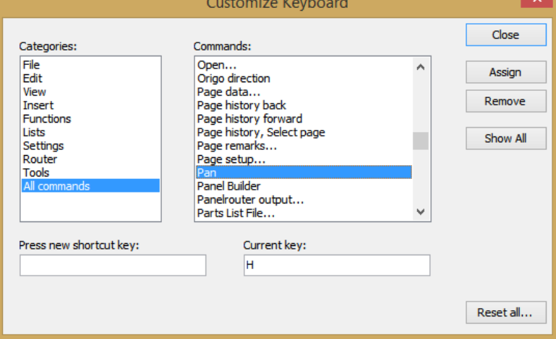

Then hit “Assign” and “Close”. Like a glove!

A couple of other handy shortcuts include:

|  |  |
| --- | --- |
| Key | Use |
| s | Symbols, hit this key to adjust symbols, and click again to place them |
| L | Line, hit this key to make lines and manipulate them |
| T | Text, used to make and manipulate text |
| Z | Zoom |
| LCTR + scroll | Zoom scroll |

You will only place symbols, text and lines when this icon is set



# Making a reference list

To make the different nodes for the sensor, battery etc. everything is made via PLC.

This means that when inserting sensors, and connecting them to the node, all that is needed is to select the I/O address, and the description, reference, name and label are automatically inserted.

## Symbol creator

Start by hitting F8, or alternatively go under “Functions” and “Symbol Menu”

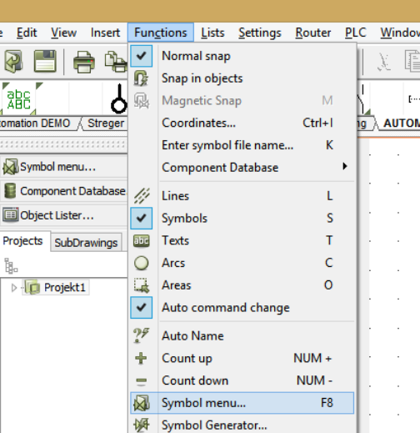

Then press “Create new Symbol”

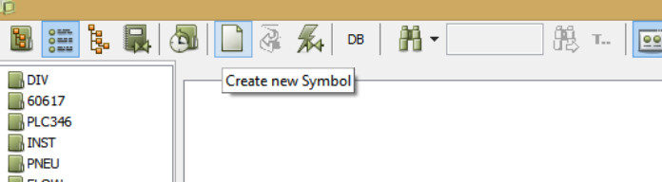

You will then see a blank page with a little rectangle in the middle

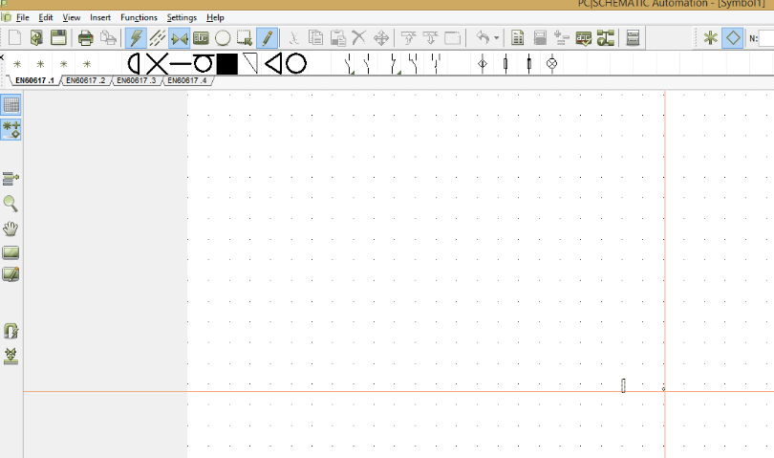

Zoom in on the little rectangle, and while in the symbol options (hit s if the two arrows pointing at each other is not already selected) hover to see the different meaning of the symbols

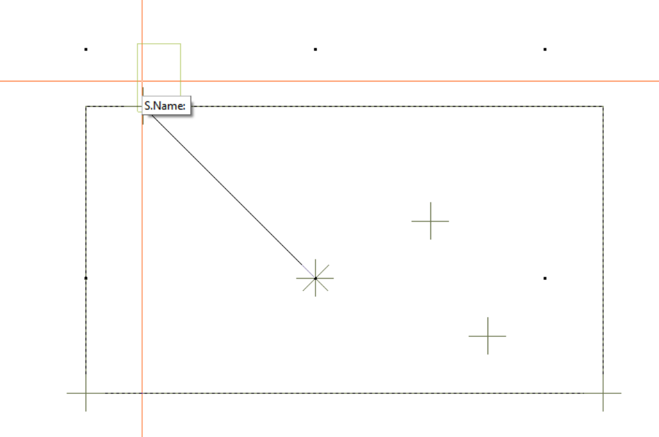

This symbol is what will be the name of the symbol as input.

To make a reference list, first, make a large square, via the square option while having “line” selected

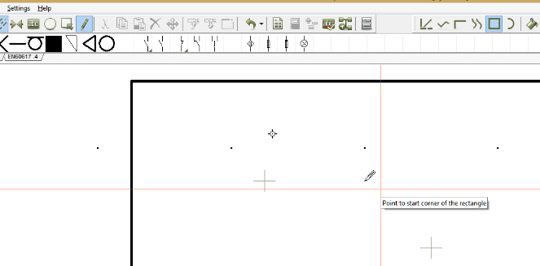It will be in this box that the reference list will be defined. After sizing it appropriately start setting up connection points.

As an example, look at the dashboard node

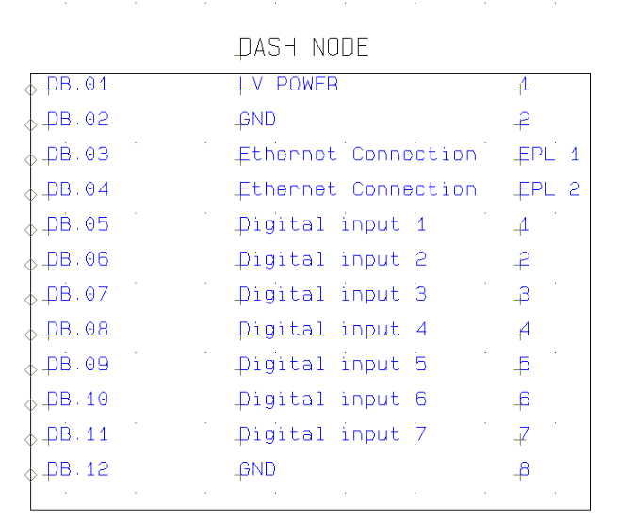

The name is the socket name, the I/O address is the pin number, starting from $0.01$ and the nupwards.

It is important to select the “Main type” as “output” and the extension as “PLC” and check the “With reference” box.

When saving this reference list, it is important to save it as a “PLC reference”.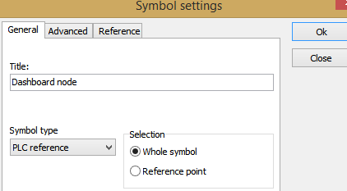

# Using the reference list

Insert the node into your project and insert some of the already predefined symbols, found in the github “Symbols needed for producing nodes”.

Place the “PLC 1 udgang” and “MODUL_1_INDGANGE” and connect them with a line.

Next, double click on the “PLC 1 udgang” and click on I/O addresses, which will produce the following picture

Select the desired connection point, and voila.

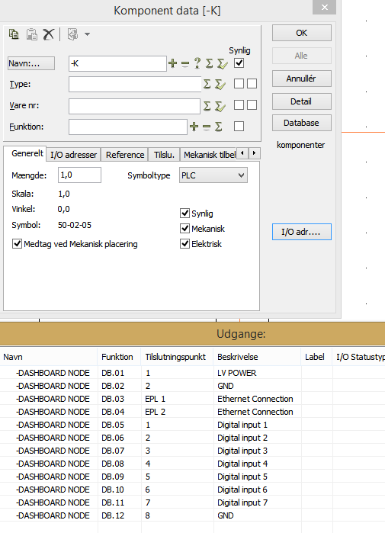

It should look like this.

